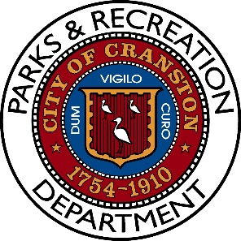

Budlong Aquatics Center Summer Schedule

Official Opening Date – Wednesday, July 15th

Official Closing Date – Saturday, August 22nd

Hours of Operation – Monday – Saturday 12noon -5pm

**Schedule subject to change based on weather**

Thank You

